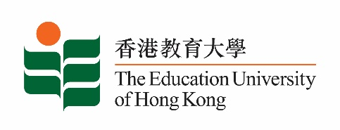
致： 傳媒機構採訪主任 23 February 2024
To : News Editors

香港教育大學2024年 2月26至 3月10日可供採訪之活動一覽
The Education University of Hong Kong (EdUHK) Events Calendar for 26 Feb – 10 Mar 2024
本校誠邀 貴機構派員採訪下列活動。傳媒查詢，請聯絡教大傳訊處（電話：2948 6050）。
You are cordially invited to cover the events below. For media enquiries, please contact the Communications Office at 2948 6050.

以下活動或有人數限制，傳媒請預先向主辦部門登記。
There may be restrictions on the number of participants for the following event(s). Please contact the respective organiser(s) / department(s) for prior registration.

- 教大大埔校園 （新界大埔露屏路十號） / EdUHK Tai Po Campus (10 Lo Ping Road, Tai Po, New Territories)

日期  Date | 時間  Time | 活動  Event | 地點  Venue |  | 主辦部門及公眾查詢  Organiser &  Public Enquiry | 備註  Remarks
2024-02-26 | 8:30 am – 3:35 pm | UNESCO and UNEVOC (Hong Kong) Symposium: Empowering Youth  Skills for green innovation: fostering green transition to  a Sustainable Future | 教大大埔校園  EdUHK Tai Po Campus |  | 主辦部門 / Organiser:  Department of International Education  國際教育學系  查詢 / Enquiries:  Dr Aysuhan Tuba SARAL  Tel / 電話: 2948 8426 | 免費入場，  歡迎各界人士參加。Free admission.  All are welcome.
 |  |  | A-G/F-08  From 8:30 until 12:10 | C- L/P -02  From 13:35 until 15:35
日期  Date | 時間  Time | 活動  Event | 地點  Venue |  | 主辦部門及公眾查詢  Organiser &  Public Enquiry | 備註  Remarks
2024-02-27 | 9 am – 4:30 pm | UNESCO and UNEVOC (Hong Kong) Symposium: Empowering Youth  Skills for green innovation: fostering green transition to  a Sustainable Future | 教大大埔校園  EdUHK Tai Po Campus |  | 主辦部門 / Organiser:  Department of International Education  國際教育學系  查詢 / Enquiries:  Dr Aysuhan Tuba SARAL  Tel / 電話: 2948 8426 | 免費入場，  歡迎各界人士參加。Free admission.  All are welcome.
 |  |  | A- 4/F – Council Chamber  From 9:00 until 12:00 | A – G/F - 08  From 13:00 until 16:30

